EGR2312 Lab Experiment N°5

Torsion on Circular Shafts – The Load-Angle Plot at Different Lengths
Note: Before reading this document, please go through the description of the Torsion and Bending Machine. The document is available in Canvas under the module “Lab Equipment Description”.
- Introduction
This experiment aims to introduce you to the concept of torsion. We will work with circular shafts of different materials, apply torsion torques to their free end, and vary their lengths. We will prove that the twist angle is linearly related to the torsion torque and investigate the effect of the length on the twist angle.
Torsion is a type of stress that appears when a moment or force couple is applied on an element. The cross sections of the element suffer a sliding by rotation about an axis normal to its plane, where tangential stresses analogous to simple shear stresses are generated.
Torsion stresses can be defined by Hooke law since they are admitted to be generated in the elastic condition of the material.

- Operation
We will first place a cylindrical shaft in the torsion machine. This ensures that one end of the shaft is fixed, while the other end is free (see figure 1).
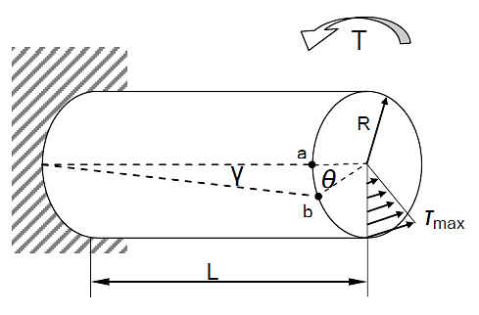
Figure 1: Diagram of the torsion test
We will then the apply a moment of torsion M_{t} at the free end, following the steps below.
- Place your bar by sliding it through the external part of 2 until is reaches 3. Fasten the bolts of 6.
- Fix the clamps in such a way that the lever 5, is located 90 degrees with respect to the plane of the guides 4.
- Move the movable supports, 2 and 3, along the guides, to reach the length desired for the test. Take note of this length.
- Once they are set at the correct distance for the test, fix the supports 2 and 3 (see figure 2).
- Locate the dial gauge on the central notch of the lever 5, sliding the articulated arm along the guides 4, fixing it to the guides with the nuts when it is in the correct position. Locate the dial gauge in such a way that it indicates 25 mm (see figure 2).
- To perform the tests, locate the weights hook 11 in the indentation of the end of the lever 5.
- Apply a force of 5, 10, and 15N and note the twist angle after each application, knowing that one turn of the indicator corresponds to 1º; 1mm→ 1º.
- Vary the length of your test bar and reapply the same weights.
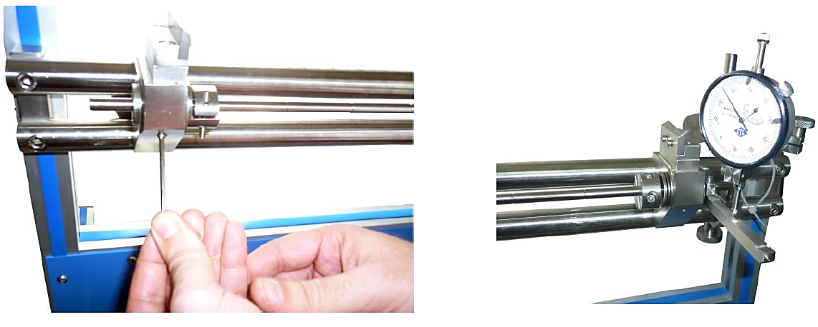
Figure 2: Clamps fixation with the set screws and location of the dial gauge
- Preparing your lab report
- You will work with the cylindrical shafts made of Aluminum and Steel.
Follow the steps above for Aluminum. Perform the twist test twice using different lengths.
Do the same thing for Steel (use the same lengths as you did for Aluminum). Report your results in the tables below.
Aluminum
L = |  | L =
Applied Load (N) | Twist Angle (deg) | Applied Load (N) | Twist Angle (deg)
5
10
15
Table 1. Data Measurements for Aluminum

Steel
L = |  | L =
Applied Load (N) | Twist Angle (deg) | Applied Load (N) | Twist Angle (deg)
5
10
15
Table 2. Data Measurements for Steel
- Plot the load-angle graphs for Aluminum and Steel at their different lengths (2 graphs for Aluminum and 2 for Steel). Fit your data points with a line and display its equation on the plot.
- From theory, what is the link between the twist angle and the applied load? What does the slope of your line thus represent?
- Compare the plots of the two materials. Which material is more resistant to twisting?
- What is the effect of changing the length of the test specimen on your results? What can you conclude?

